[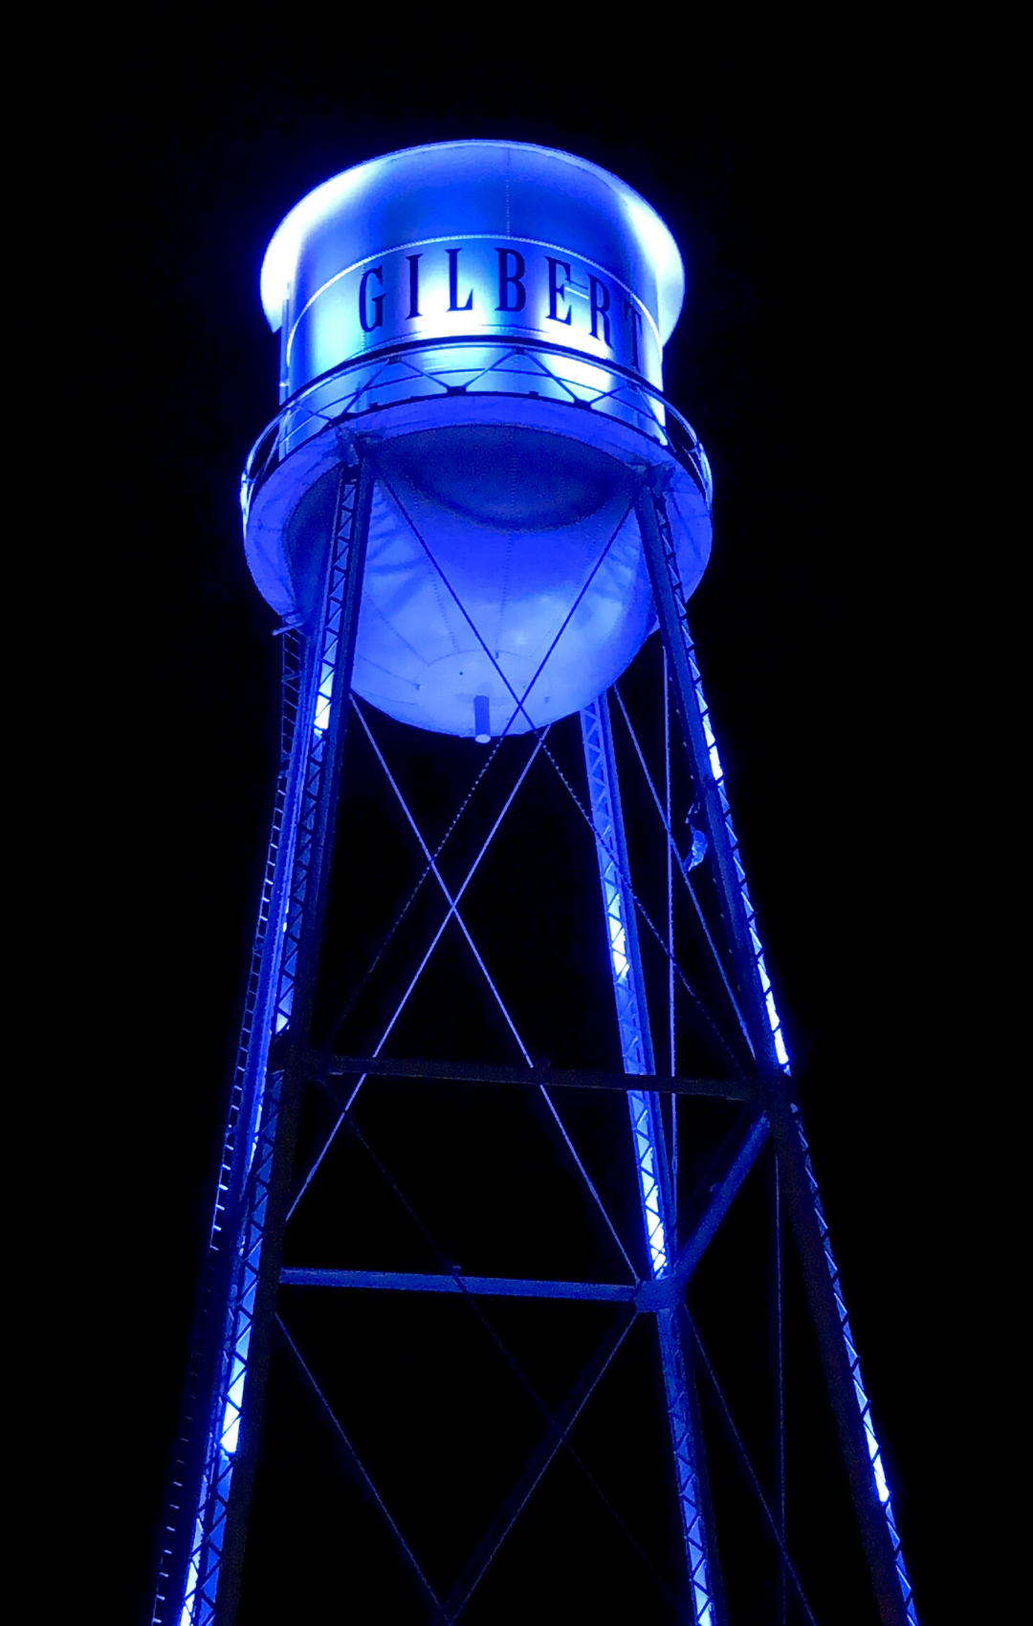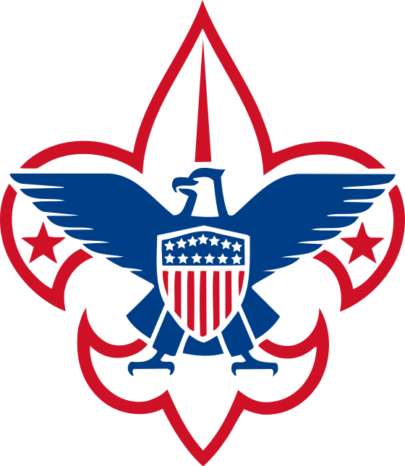](https://beascout.scouting.org/)

*\*image of Gilbert water tower in blue.*

*\*logo of Scouts BSA*

The Town of Gilbert Honors National Scouting Day

Feb 8th

On February 8, 1910 the Boy Scouts of America was established to “*prepare young people to make ethical and moral choices over their lifetimes by instilling in them the values of the Scout Oath and Law.*”

Around this day every year Scouting units in the USA celebrate the anniversary with Blue and Gold Banquets. These celebrations include recognizing our adult and parent volunteers who make the programs possible for our scouts as they progress through Cub Scout ranks all the way to Eagle Scouts.

This year Cub Scout Pack 88 of Gilbert AZ has requested the iconic Downtown Gilbert Water Tower be lit in Blue and Gold to help us celebrate. By living the values and traits of the Scout Oath and Scout Law scouts become better citizens and leaders within their communities. Thank you to the Town of Gilbert for recognizing the values of scouting in the community.

If you are interested in joining scouting in Gilbert, please visit: http://pack88gilbert.info/

If you live outside of the Gilbert area and are interested in scouting, please visit:

https://beascout.scouting.org/